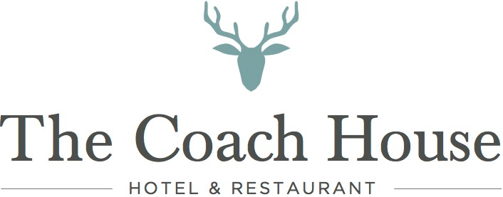

Brunch Menu

90 minute slots available between 11am and 1pm
By reservation only

£35.00 per person

Choose a dish from the menu below

Buttermilk fillet of chicken burger, cheese, smoked tomato chutney served with chips.
**
Northumberland steak burger, cheese, chipotle mayonnaise served with chips .
**
Deep fried fillet of haddock, chips, mushy peas.
**
Traditional Northumbrian breakfast. -Bacon, sausage, hash brown, mushrooms, black pudding baked, beans, with a choice of fried, poached or scrambled egg.
**
Vegetarian breakfast.- Vegan sausage, hash brown, mushrooms, tomato, baked beans, with a choice of fried, poached or scrambled egg.
**

American style buttermilk pancakes, smoked bacon and maple syrup or seasonal berries, honey and Greek yoghurt.
**
Smoked salmon, scrambled egg and toasted sourdough.

Enjoy with unlimited
MIMOSA/PROSECCO
HOUSE RED/WHITE/ROSE WINE
DRAUHT LAGER / DRAUGHT CIDER
TEA/COFFEE
FRUIT JUICE

